Analysing Neighbourhoods of

Manchester For Starting A New Restaurant.

Syed Faisal Ali Shah

IBM Applied Data Science 03.25.2023

# Introduction

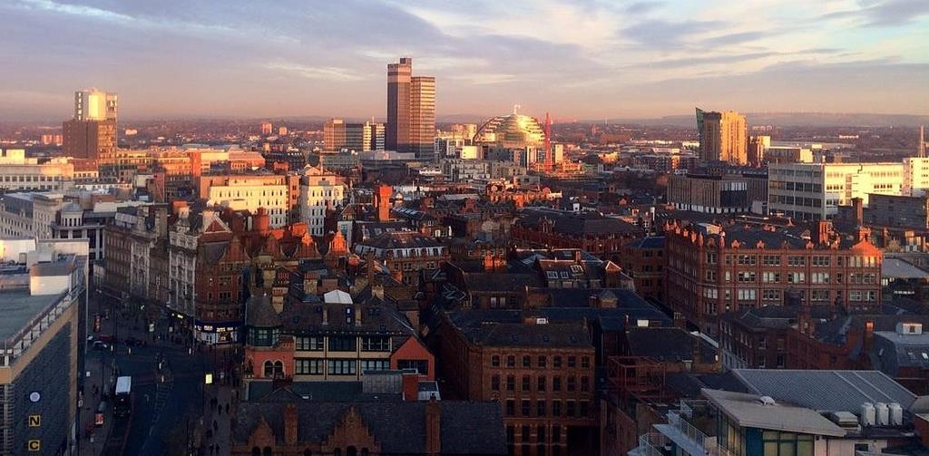

### Manchester: One of the biggest cities in UK

* United Kingdom's second-most populous urban area, with a population of 2.9 million
* The population comprises of people of various ethnicities from all over the world

# Business Problem

### Start a restaurant

* Neighbourhood that is most likely to give a good business

Data

### Neighbourhoods of Manchester

* + Neighbourhoods of Manchester wikipedia page through data scraping.

### Geographical coordinates of the neighbourhoods

* + Using GeoPy library.

### Venue data from FourSquare

* + Using FourSquare API

## Methodology

### Feature Extraction

* + One Hot Encoding

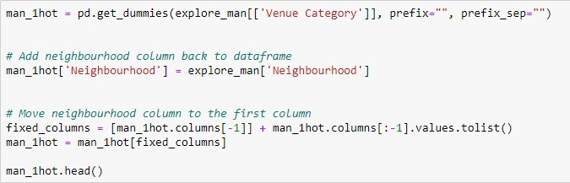

### Unsupervised Learning

* + 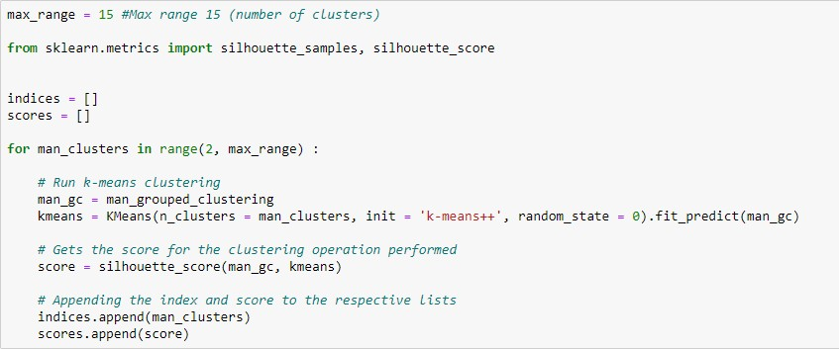K-Means Clustering

### Plotting

* + Folium

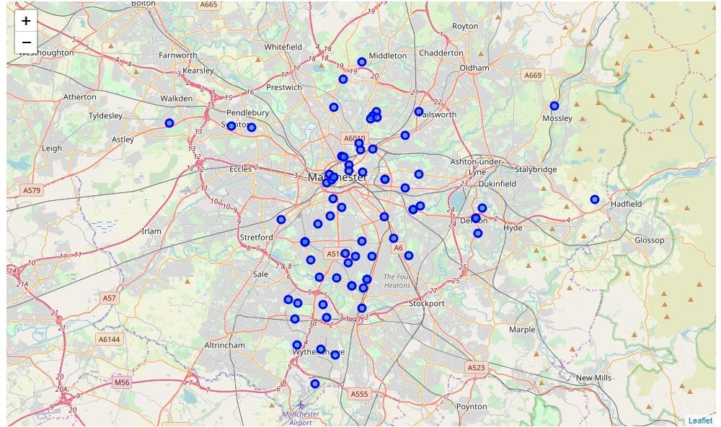

## Results

### C:\Users\shaba\Pictures\Screenshots\Screenshot (125).pngVisualization of clusters

* After visualising the clusters, the individual clusters were studied and some important conclusions were derived. The neighbourhood that had the most number of restaurants was cluster number 4.

# Discussion

* + Most suitable neighbourhoods for starting the restaurant business are present in the cluster number 4.
  + Our K-Means model worked perfectly and successfully clustered similar neighbourhoods together.
  + After studying all four clusters, it is recommended to the client that neighbourhoods such as Barlow Moor, Brookelands and Hyde Newton (Ward) that fall in cluster 4 look like good locations for starting their restaurant business.
  + The client can go ahead and make a decision depending on other factors like availability and legal requirements that are out of scope of this project.

# Conclusion

#### Data analysis and machine learning techniques used in this project can be very helpful in determining solutions of certain business problems.

* + Python’s inbuilt libraries such as GeoPy, Folium and BeautifulSoup make it very easy and effective to analyse a geographical location.

#### In this project we studied the neighbourhoods of Manchester city and came up with a recommendation of neighbourhoods where our client can start their restaurant business.